1 create table

create table customer(

cust_no int auto_INCREMENT,

cust_name char(20),

cust_street varchar(15),

cust_city varchar(20),

PRIMARY KEY(cust_no));

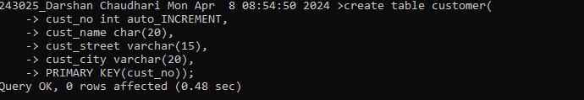

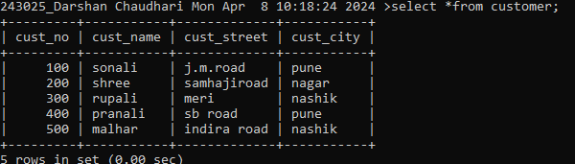

2.

create table account(

acc_no int primary key,

acc_type varchar(10),

balance float(8,2),

cust_no int ,

constraint fk_1 foreign key(cust_no) REFERENCES customer(cust_no));

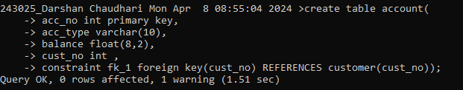

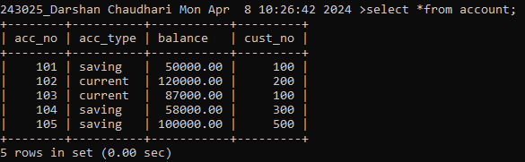

3. create table branch(

branch_no int primary key,

branch_name varchar(20) not null,

branch_city varchar(20),

acc_no int ,

constraint fk_2 foreign key(acc_no) REFERENCES account(acc_no));

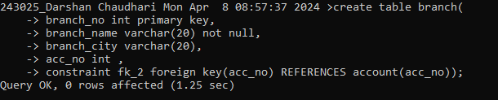

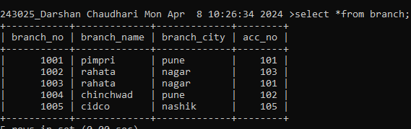

4.

create table loan(

loan_no int primary key, not EXISTS

loan_amt DOUBLE(9,2),

no_of_years int,

cust_no int,

branch_no int,

constraint fk_3 foreign key(cust_no) REFERENCES customer(cust_no));,

constraint fk_3 foreign key(branch_no) REFERENCES branch(branch_no));

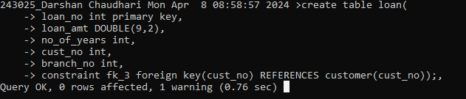

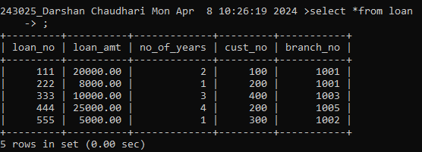

5. insert into customer values('sonali','j.m.road','pune');

insert into customer values( 400,'pranali','sb road','pune');

insert into customer values( 500,'malhar','indira road','nashik');

insert into customer values( 200,'shree','samhajiroad','nagar');

insert into customer values( 300,'rupali','meri','nashik');

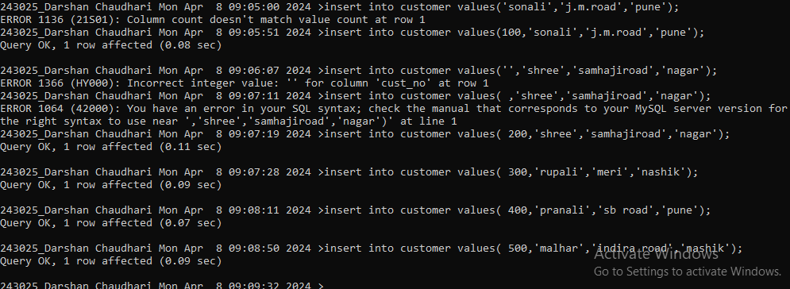

6.

insert into account values(101,'saving',50000,100);

insert into account values(102,'current',120000,200);

insert into account values(103,'current',87000,100);

insert into account values(104,'saving',58000,300);

insert into account values(105,'saving',100000,500);

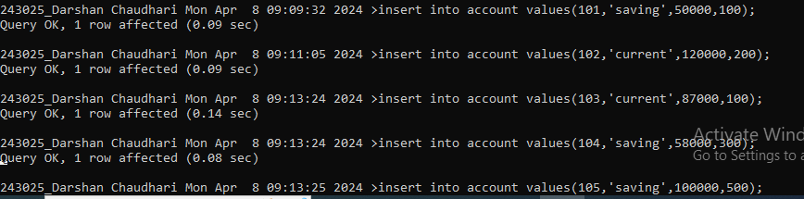

7. insert into branch values(1001,'pimpri','pune',101);

insert into branch values(1002,'rahata','nagar',103);

insert into branch values(1003,'rahata','nagar',101);

insert into branch values(1004,'chinchwad','pune',102);

insert into branch values(1005,'cidco','nashik',105);

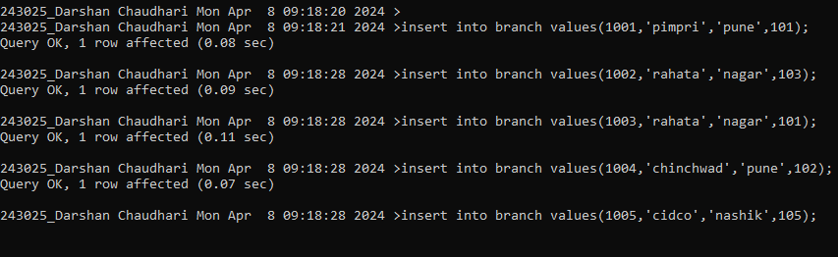

8. insert into loan values(111,20000,2,100,1001);

insert into loan values(222,8000,1,200,1001);

insert into loan values(333,10000,3,400,1003);

insert into loan values(444,25000,4,200,1005);

insert into loan values(555,5000,1,300,1002);

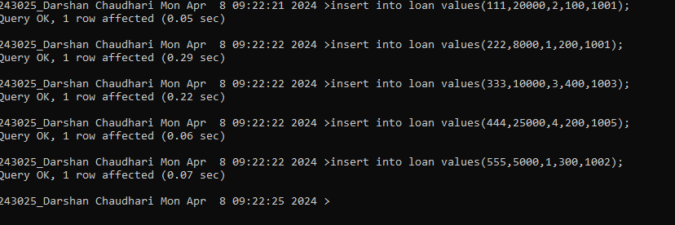

9. find name of loan >10000

select cust_name from customer c where cust_no = (select cust_no from loan l where c.cust_no=l.cust_no and loan_amt > 10000);

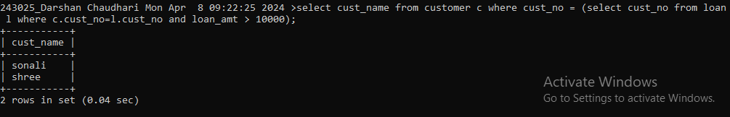

Mongo q3

db.restaurant.find({name:/^W.*d$/},{name:1,restaurent_id:1,borough:1,zipcode:1,_id:0})

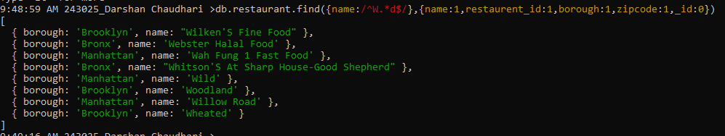

Mongo q2

db.restaurant.find({'address.coord':{$lt:-95.754168}},{_id:0})

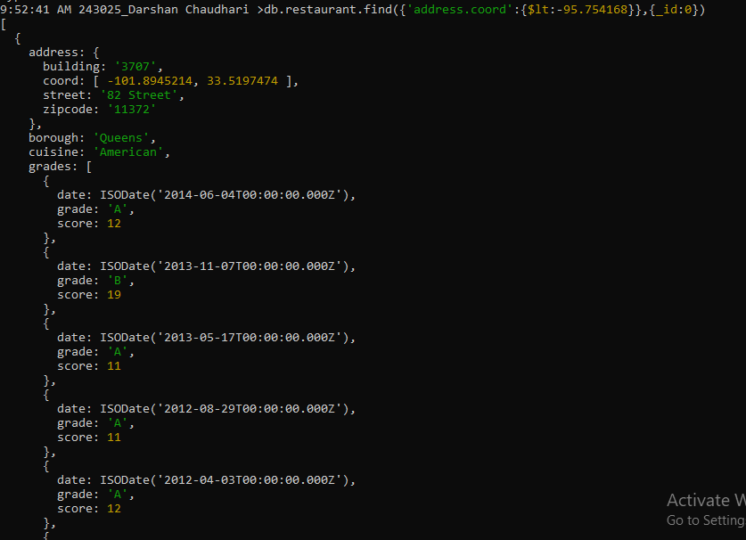

fthjyugfj